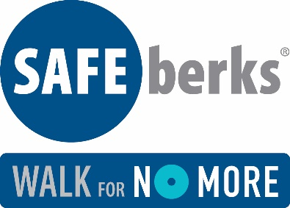
Committee Meeting Minutes
Friday, April 12, 2019
9:00 am at Safe Berks

Present: Mandy Acuna, Judy Aulenbach, Jan Cremer, Margie Davis, Diane Duff, Mindy McIntosh, Pastor Steve Ohnsman, Michele Pole, and Francine Scoboria.

Event Update
We are 2 months from walk. Website is up and running. Many posts on social media and several have been shared. $225.00 in walker money to date.

Dr. Kimball offered us to use the All About Children parking lot for excess or volunteer parking. She will verify with Reading Hospital and confirm with us.

Review Potential Sponsors
New sponsors are VF at $2,500. Caron at $2,500 and OPx Partners at $500.

McDonald’s agreed to still provide breakfast. We will need two dedicated volunteers to help them transport the food across the street and monitor when the items are running low.

Prospective Sponsor list was reviewed and committee members were asked to make follow up calls. Mindy will send sample wording that can be used in correspondence.

Need a new contact person at M&T Bank – Bill Long recently retired. If anyone has a new contact – please let Mindy know. Also, if you have any new prospects to add to our list, please give to Mindy and she will send letter out.

Online Registration Update
Francine gave an on-line demonstration and went through all the options to give or donate on-line. Website seems to be working well and user friendly.

If anyone has any questions or issues, please call or e-mail Francine.

Discuss plans to recruit Walkers – Subcommittee
We will be sending an e-mail out to all past participants from Mandy next week. With it, we will have information on where the money goes and how it helps Safe Berks.

Francine can send e-mails out to registered walkers with different Safe Berks facts, stories about why people walk, etc. We should work out an e-mail schedule with what info we want and when to send.

We distributed a registration form that can be used for those that don’t like to register on-line.

Andi from Y102 will put a team together and ask for listeners to join her team

Publicity

Publicity Committee met and Francine reviewed some of the highlights:
- Walk will be highlighted in our upcoming Spring Newsletter
- E-mails blasts are sent out periodically and include WFNM info
- Sponsor sign is being created and shared on our website and social media
- We will have a sign making event on May 6th. We will also paint rocks that can be hidden in West Reading leading up to the walk. Will ask the Reading Eagle to come and give us press.
- We are advertising in Women 2 Women, On the Avenue and Sinking Spring Twp Parks & Rec
- Our BCTV show on 5/14/19 will highlight the walk.
- Submitted info to Berks County Living magazine for inclusion in their issue calendar
- Use #SafeBerksWalk when posting on Social Media.

We will have a table at West Reading’s Craft Pretzel and Beer Festival on April 27th. Need volunteers to help man the table between 11:00 am and 7:00 pm. Will promote the walk and Camp Safe Berks in addition to everything else we usually have.

Entertainment Update
Mindy will send e-mail out to last year’s entertainers seeing if they would like to join us again. Will be smaller set up and perform on the street.

Next Meeting Date
Monday, May 13, 2019

