Safe Berks

Board of Directors Meeting Agenda

Date August 23, 2018 @ 8:00 AM

Location: Safe Berks Center, 255 Chestnut St., Reading

Conference Call Information: Dial in No. 1-877-860-3058
Guest Passcode 7148513#
______________________________________________________________________________

Executive Session – CEO Compensation Discussion

Education: Leadership Berks Marketing Plan – Mary Kay, Mindy & Francine

- Call to Order - Vicki Ebner
- Consent Agenda
  - Approval of Minutes: June 28, 2018
  - Executive Committee Minutes – August 13, 2018
  - Finance Meeting Minutes – August 15, 2018
  - Development Committee – August 7, 2018
- Finance
  - Budget
- Development Committee - Diane Duff
- President’s Report
- Old Business
- New Business
- Announcements
- Adjournment
Upcoming Meetings:
Finance Committee – September 19, 2018 8 AM
Executive Committee Meeting – September 19, 2018 9 AM
Next Board Meeting – September 27, 2018 at 8 AM
New Board Member Orientation Oct 3 from 3-5PM) and Meet & Greet (5-6:30 PM) @ Berks County Community Foundation, 237 Court Street

Safe Berks

Board of Directors Meeting Minutes

Date June 28, 2018 @ 8:00 AM

Location: Safe Berks Center, 255 Chestnut St., Reading

Conference Call Information: Dial in No. 1-877-860-3058
Guest Passcode 7148513#

Attending: Karima Archie, Nina Bohn, Tina Boyd, Joe Cicala, Karen Cook, Carlixta De LaRosa, Diane Duff, Vicki Ebner, Amanda Jackowski, Jay Mahoney, Michele McCartney, Steve Ohnsman,
Telephone: Tim Marks
Excused: , Mary Ann Moffitt, Susan Fromm, Mark Wallace
Absent: Jonathan Encarnacion
Staff:, Mary Kay Bernosky, Jasmine Suarez

The regular board meeting was preceded by an Executive Session to discuss the CEO evaluation.

Vicki Ebner called the meeting to order at 8:06 AM.
Mary Kay informed the board that Carolyn Holleran is encouraging us to run another Capital Campaign. She feels the time is right since no other agencies are on the books for a campaign right now. Before we would consider that the Board would need to have a discussion about it and if most agreed, we would have a feasibility study done. Rick Blaine conducted the feasibility study for the building at 255. Mary Kay feels his work is excellent; that Rick knows this community and has worked with a number of agencies. Mary Kay will be talking to Virginia Rush this afternoon and will report back to board.

Mindy provided an update to the Board on the Walk For NO MORE. Right now our total is $33,984. This was our best year ever. The Board team came in first for donations, Jan came in 4th and Mindy 6th. Teams are definitely the way to go. Raffle income was lower than last year, but that was expected since we didn’t spend a lot of time or effort obtaining raffle items. This year we had 6 prizes – last year we had 24. We had over 200 walkers and received front page coverage on both A1 & B1 sections of the Reading Eagle.

Our in-kind sponsors – McDonalds, Reading Eagle, VA Productions and the Blue Knights provided items of great value to the walk. Jay Mahoney proposed that these organizations should receive thank you letters from the Board.

- Consent Agenda
  - Approval of Minutes: May 24, 2018
  - Executive Committee Minutes – June 20, 2018
  - Finance Meeting Minutes – June 20, 2018
  - Employee Retention Committee Minutes – June 11, 2018
Joe Cicala made a motion to approve the Consent Agenda; Tina Boyd seconded the motion. Motion Carried.
- Finance
Financial Statements – May 2018
Jasmine reviewed the financial highlights with the board. There was some discussion on the ratios that were presented.

Jay Mahoney made a motion to approve the financial statements with the understanding that the ratios appearing in the highlights are reviewed once again at the August Finance meeting.: Steve Ohnsman seconded the motion. Motion carried.

- Governance Committee - No report

- Development– No additional report.

- CEO Report

Mary Kay introduced our Inside Berks Program teacher from Exeter. The program allows teachers to shadow those in business to help provide them with more information for their students about possible careers. This is the first of 4 days that Kristy will spend with Mary Kay and they have a very busy schedule.

She also reported that as a result of a meeting at Kutztown we will have an onsite presence on campus and will also be allowed to do some programming for students.

TELP is still scheduled to close tomorrow.

- Presidents Report
Jen Ebersole is still looking for some Camp SAFE Berks volunteers. If you should have time the week of July 23 and would like to volunteer, please contact Jen.

Our Director of Counseling has decided not to accept our offer of employment. Mary Kay will wait until the new COO starts and will have her reviewing candidates for the Director of Counseling position as soon as she starts.

Reminder to all Board members that August starts our new schedule of meetings. We are scheduled for August 23rd from 8 am – 10 am. Please mark your calendars accordingly.

The Board Orientation for new members will most likely occur in October. Vicki will check with Mary Kay regarding a date.

Old Business – None

Amanda Jackowski made a motion to adjourn the meeting. Steve Ohnsman seconded it. The meeting was adjourned at 9:35 a.m.

Upcoming Meetings:
Finance Committee – August 15, 2018 8 AM
Executive Committee Meeting – August 15, 2018 9 AM
Next Board Meeting – August 23, 2018 at 8 AM

Respectfully submitted,

Jan Cremer
Executive Assistant/HR Coordinator

CEO Report to the Board
August 23, 2018
It has been quite a busy summer. The following are highlights from the months of July and August:

Staff Announcements
Elizabeth Garrigan, our new COO began her tenure on 7/9th.
Mindy McIntosh was promoted to Development Director effective July 1st
Danielle Palermo was promoted to Director of Counseling effective August 13th.

The following staff have separated from Safe Berks:

Amber Shamonski and Chris Dowhower – both Community Educators.

The following positions remain vacant:

2 Counselors in Counseling Department
1 Safe Healing Coordinator/Counselor in Counseling
2 Community Educators
1 SART (Sexual Assault Response Team) Coordinator – NEW POSITION

Board Candidates

We will be asking the Board to approve a slate of candidates for Board positions in September. Our Board maximum is 21 and minimum is 9. We currently have 3 vacancies due to resignations and we have 3 additional members who are rotating off. Those members are Mary Ann Moffitt, Vicki Ebner, and Karima Archie.

The following are the candidates we are proposing for membership:

Jamal Abadola – former Township Manager of Muhlenberg, spouse of Carla Abadola, former Board member and Albright Professor.

Barbara Boland – Guidance Counselor at Conrad Weiser and member of Walk for No More Committee,

Denise DiMascio, Vice President Human Resource Development for TouchPoint Inc, member of Walk for No More Committee.

Dr. Eve Kimball, Pediatrician and owner of All About Children, West Reading, PA.

Sherri Berricker, Western Berks EMS and member of Leadership Berks Team that worked on the Marketing Plan for Safe Berks.

The following is the proposed slate of Officers to Elect in September:

President – Nina Bohn
Vice President – Amanda Jackowski
Treasurer – Carlixta dela Rosa
Secretary – Diane Duff

Vicki Ebner as immediate past President will remain a member of Executive Committee and one member of the Board at large will be appointed to the Executive Committee.

Committee Chairs will be appointed/ re-appointed officially by the President in September but given the necessity for things to continue to move, the following have agreed to serve as Chairs:

Timothy Marks – Chair of Health Care Advisory Board
Diane Duff – Chair of the Development Committee

We will be presenting a draft of our Budget for review and comment in August before final ratification in September.

We have scheduled Board Orientation for Wednesday October 3rd at 3pm at the Berks County Community Foundation. A Board/staff mixer will follow.

Grants

We have been informed we will be receiving $492,000 in additional VOCA funds for a 30-month period beginning December 2018. This is new money. We must file a grant application by September 7th, 2018 and we are anticipating using this for MAP (Medical Advocate Program) positions to be embedded at Tower Health, Penn State St. Jos, and the Community Health Center, along with an Economic Justice/Sustainability Advocate and the Sanctuary Model training.

In addition, there are $46 million in Competitive VOCA funds, 75% of which are available to urban counties (Berks is an urban County) and we have been working with the Caron Foundation to develop a proposal for that funding.

Capital Campaign
I have been continuing to pursue this discussion with the Review Board and Carolyn Holleran and believe this is something we can pursue. I have asked for a proposal for a Feasibility Study from RR Blaine to at least get a sense of that cost. I will discuss this further at the Board meeting.

Celebration of Peace

Save Monday December 10, 2018 for our COP at the Doubletree. Voices for Change Honorees are Koinos Community Church and the Power of the Purse of Berks County. Vision for Peace Honoree, Dr. Tom Flynn, Alvernia University. Co-Chairs for the event are Helen and Steve Najarian and Susan and Mike Fromm.

A list of current Committees and Chairs will be distributed in August as well.

Our longer meetings begin in August so please plan accordingly! We have a lot to accomplish in the next few months.
Safe Berks Board of Director’s Report – May 2018
Education and Outreach Department
Jennifer Ebersole, Director

Staff Update:
Amber Shamonsky (Community Educator) separated employment on July 18th.
Chris Dowhower (Community Educator) separated employment on July 30th.
Natasha Turczynski (Community Educator) is on maternity as of August 14th and will return in mid-October.
The Director is currently interviewing for both open community educator positions and is eager to fill them as soon as possible.

Education, Awareness, Presentations, Trainings:
Schools: Glenside Elementary School Back-to-School Night
Colleges: Sexual Violence presentation to Alvernia College Peer Educators; tabling at Albright College Move-In Day
Community Outreach: Hosted a public “Mindful Meditation” seminar in partnership with Reading PRIDE Celebration to display support for their festival. Tabling at the following community events: AmeriHealth Caritas Community Baby Shower; National Night Out for Fleetwood, Spring Twp, Antietam, and Muhlenburg; Berks Community Health Center’s three community fairs; and Friend Inc. Community Services Health Fair (Kutztown). Meeting with the Caron Treatment Centers to discuss prevention education partnership opportunities.
Staff Development/Prevention Education Trainings: None
Community Presentations: Medical Advocacy to Reading Hospital SANE Nurses
Media/Communications: BCTV August program featuring a recap on Camp Safe Berks.

Camp Safe Berks:
Camp Safe Berks took place July 23-27 at Albright College. While we had four camper cancellations the week leading up to Camp, we are pleased to report 19 campers participated in the entire week of Camp. Overall, Camp was a HUGE success, especially considering this was a building year for Education and Outreach staff, none of which attended Camp in the past. The campers were overwhelmingly engaged, eager to learn, and passionate about the topics covered. Feedback from our camper survey suggests the same (see attached CSB Survey Feedback Results). A SPECIAL THANK YOU to Safe Berks Board members - Steve Ohnsman for volunteering the entire week of camp as a “Conocimientos” group leader and facilitator and Karima Archie for co-facilitating on Racial Justice Day. Our Department hosted a facilitator/volunteer debrief on August 9th. A Camp Safe Berks reunion is scheduled for September 12th. Follow-up activities will be scheduled throughout the year to further engage 2018 campers and develop a community impact project.

CAMP SAFE BERKS FEEDBACK SURVEY RESULTS

On a scale of 1 to 5 (with 1 being the least and 5 being the most) campers rated several factors related to each day of Camp that was beneficial to them. Please reference the attached spreadsheet for individual results and the Camp Safe Berks Feedback Survey form for complete questions.

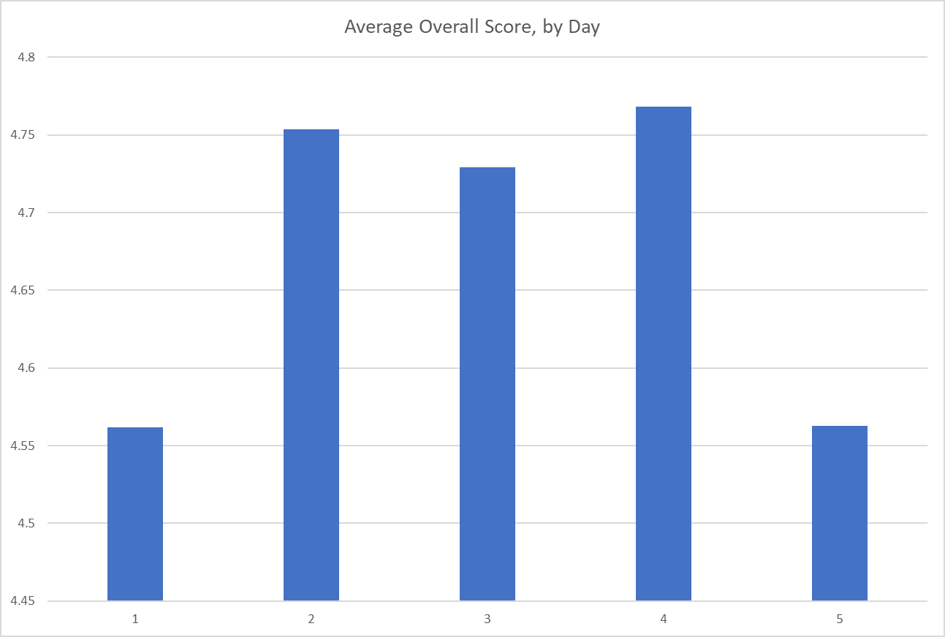

On a scale of 1 to 5, with 1 being not likely and 5 being very likely…

Our campers who are likely to recommend Camp Safe Berks to people they know overall scored a 4.7 out of 5!!!!!!

In Their/Your Words…
(Actual responses from the feedback survey)

What Worked Well
- We had fun activities while still learning about serious issues
- LGBTQ+ Justice Day stood out because it helped me to express myself more
- Captain’s Coming!
- Don’t change anything, I really liked everything about Camp!
- I liked that this camp is at a college
- Gender Justice Day stood out because everyone learned more about each other’s experiences
- Meeting new people, making new friends everyday
- I made friends and I learned a lot about things and I had a great time with my favorite leader, Mr. Matt!
- LGBTQ+ Just Day stood out to me because it was very educational
- LGBTQ+ Justice Day stood out because it helped me come to terms with my sexuality (several campers said the same thing)
- Youth Justice Day – favorite part was making the hearts and meeting people who are interested in the same thing I am.
- Gender Justice Day – my favorite part of this day was the step-out because it really opened my eyes
- The swimming pool
- Thursday stood out the most and was most impactful because of the talent show
- Cook out
- Gender Justice Day stood out the most because it shocked me with how much I related or stepped out.
- I liked how small it was and I liked the German Shephard that was outside everyday
- I think all the days were equally impactful with the things they talk about
- My favorite part of LGBTQ+ Day was that people in this community were comfortable talking to us.
- LGBTQ+ Justice Day really stood out because students who may have been ostracized in their communities at home found safety in the community here.
- The food and the facilities were wonderful. There wasn’t anything that I didn’t like.
- Meeting a lot of open-minded people
Opportunities
- Actual games for outside instead of just a basket of balls
- Day 5 was crazy and it was no one’s fault, just the last day
- For LGBTQ+ Justice Day, I would have liked there to be a speak-out (several answered in this way)
- More activities where we put ourselves in the less power people’s shoes
- Learn more about economics
- Maybe make it less serious/lighten-up when something gets deep
- For Gender Justice Day, I would change the way that trans/non-binary people were singled out.
- Limit some of the speak-outs – too much repetition
- Longer rec time
- Explain that straight people aren’t making fun of LGBTQ+ if we want to hold the flag
- I would change Economic Justice Day. It was not very relevant. I felt we could cover more important things
- For Gender Justice Day, I would change the fact that trans/non-binary people went with the women. I felt awkward.
- I would not recommend having Economic Justice Day
- Talent show could be changed or better planned
- More active and moving activities
- More free time
- If we could change it up and let the kids be more in charge
- Change Racial Justice Day because the white people couldn’t speak their mind on how they felt because people of color can be racial
- Going outside more (if it doesn’t rain)
- Have a movie night
- I think I would add more activities or extend the Camp so we can learn more
- I think it would be better if we could have a room or two more, just so we would be in different seating arrangements and would have a different experience
- Maybe a discussion about how people of color are portrayed in the medial would be helpful
- For Youth Justice Day, perhaps a deeper conversation or activity differentiating between adultism and responsible parenting would be helpful
- More moving around physically, less sitting

Legal Department Director’s Report
Diane Ellis, Director of Legal Services
July and August, 2018

Legal Department Statistics

June, 2018

Total number of clients served by legal advocates and paralegal – 78
Figures include 21 court accompaniments to hearings w/clients
and 2 individuals who received services through the Title IX program

Total number of clients represented by attorneys –106
Figures include 78 individuals represented in court

July, 2018

Total number of clients served by legal advocates and paralegal – 124
Figures include 18 court accompaniments to hearings with clients
and 3 individuals who received services through the Title IX program

Total number of clients served by attorneys – 104
Figures include 79 individuals represented in court

LAP Statistics

June, 2018

Total lethality screens performed by Police: 9*
Number of screens indicating high danger of lethality: 8
Number of individuals refusing to participate in screening: 0
Number of Police calls to Agency hotline: 8
Number of individuals who agreed to speak to hotline: 6
Number of individuals who accessed additional Agency services: 1

*1 screen performed by West Reading PD; 8 performed by Reading PD

July, 2018

Total lethality screens performed by Police: 15*
Number of screens indicating high danger of lethality: 11
Number of individuals refusing to participate in screening: 0
Number of Police calls to Agency hotline: 7
Number of individuals who agreed to speak to hotline: 5
Number of individuals who accessed additional Agency services: 8

*8 screens performed by Reading PD; 5 by West Reading PD; 1 by Amity Township PD; 1 by Bern Township PD

Development Report – July 2018
Mindy McIntosh, Director of Development

Walk For NO More
Had event wrap up meeting on 7/12/18
Closing walk with nearly $40,000 raised.
Committee will meet again in late Fall to start planning for next year
June 15, 2019

Development Committee
Working with Diane Duff, Development Chair in setting goals
Selected potential community members and invited them to serve on our Committee
First meeting will be in August
Working on Development Plan

Celebration of Peace
Monday, December 10, 2018, 6 pm -8 pm at DoubleTree
Host Committee Co-Chairs: Helen & Stephen Najarian & Susan & Michael Fromm
Vision for Peace Honoree: Dr. Thomas F. Flynn, President, Alvernia University
Voices for Change Award Winners: Koinos Community Church & Power of the Purse Berks County
Save the Date cards being printed and mailed in August

Volunteers
Continuing to recruit volunteer groups to cook dinner
Participating in many UW agency and community fairs
Getting info out to potential volunteers about 66 hr training in September

Donations
Anchored by Grace came in with a trailer full of clothes, shoes and accessories and let all the moms and children take any items they wanted. This will be a bi-monthly event. Will come back in September.
Met with individuals from Mary’s Shelter to see how we can work together and share excess resources and fulfill donation needs.
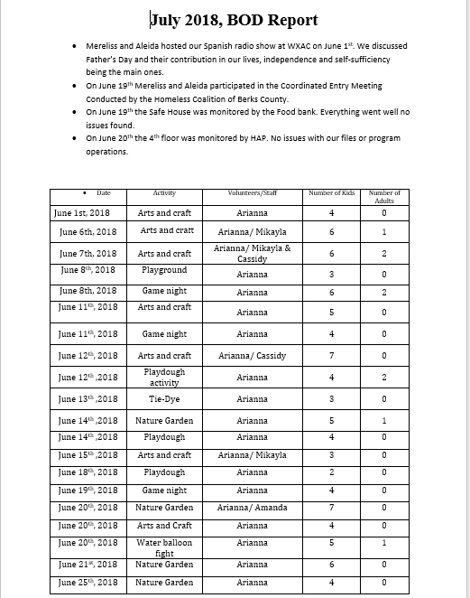
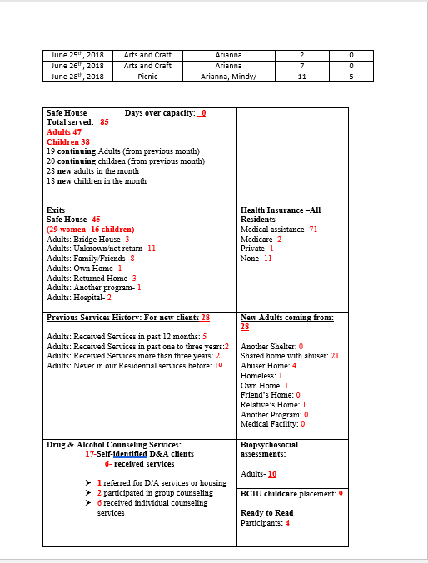
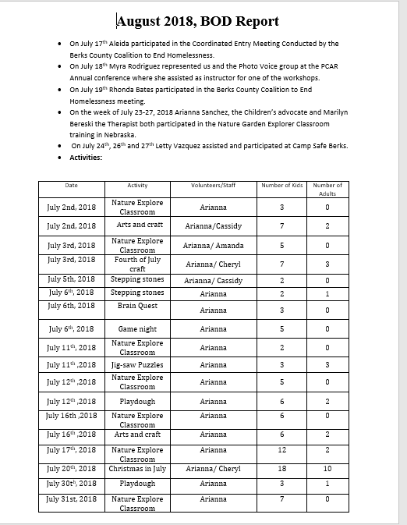
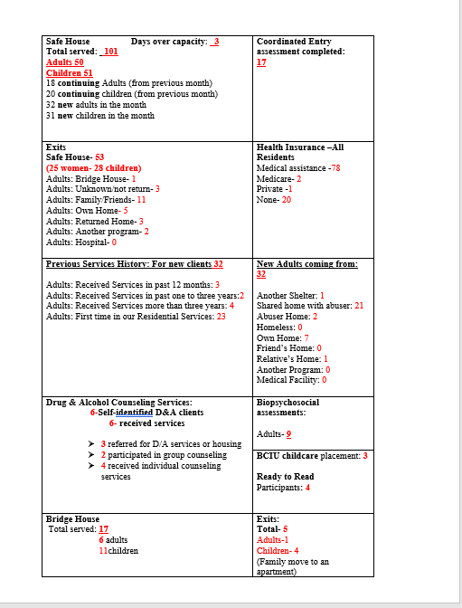

COO Report to the Board
August 14, 2018

Began position as COO on 7/9.

Spent most of the month meeting with Directors and other staff in order to get acquainted and learn the roles/responsibilities throughout the agency.

Met with each direct report and set up recurring day/time slots for ongoing Supervision. Toured the Safe House and Bridge House.

Participated in Safe House’s Christmas in July-what a wonderful event for our residents! The staff did an amazing job!

Visited Safe Berks Camp to experience the great work by our staff, volunteers and campers.

Attended numerous meetings such as SANE Monthly meeting, Dependency Court Meeting, DV Committee Mtg with Tower Health, Facilities Committee, Safety Committee, WFNM Meeting, BCAHT Meeting, and UWBC meeting.

Attended a meet/greet/tour with Melissa H. at CAC and attended an MDIT meeting and CAC CM meeting.

Spent time reviewing files and documentation left by Christine as well as written and electronic resources from PCADV and PCAR.

Began interviewing for Director of Counseling so we can then begin filling vacant Counselor positions.

Executive Committee Minutes

A meeting of the Executive Committee occurred on Monday August 13, 2018 at 11:30 am at Safe Berks. Present were Vicki Ebner, Nina Bohn, and Diane Duff; Mary Ann Moffit and Amanda Jackowski participated by phone.
Mary Kay updated the committee on recent staff changes:
Elizabeth Garrigan, our new COO began her tenure on 7/9th.
Mindy McIntosh was promoted to Development Director effective July 1st
Danielle Palermo was promoted to Director of Counseling effective August 13th.

The following staff have separated from Safe Berks:
Amber Shamonski and Chris Dowhower – both Community Educators.

The following positions remain vacant:
2 Counselors in Counseling Department
1 Safe Healing Coordinator/Counselor in Counseling
2 Community Educators
1 SART (Sexual Assault Response Team) Coordinator – NEW POSITION

A discussion was held about the new VOCA funding, both competitive and noncompetitive. Those grants are due 9/7/18.
Mary Kay will continue to work with Mindy on developing a case statement for a major giving campaign to pay down the mortgage.
The COP and new Development Committee was discussed, and Diane will be reaching out to Board members regarding soliciting potential sponsors.
A discussion about the new Board members and Officers was held. It was determined that Nina and Mary Kay will meet with Carlixta as a new Officer to discuss fiduciary duties and confidentiality.

The meeting adjourned at 1:15 am.

Safe Berks Finance Committee
Minutes
6-20-18
Present: Vicki Ebner, Amanda Jackowski, Diane Duff, Doug Rauch, Nina Bohn
Absent: Marjorie Aherns, Mary Ann Moffit, Carlixta De La Rosa, Jay Mahoney, Steve Pottieger,
Staff Present: Mary Kay Bernosky (CEO), Jasmine Suarez (CFO), James Keaton (Staff Accountant).
Meeting called to order at approximately 8:00 A.M. by Amanda Jackowski
- Presented by Jasmine Suarez, discussed by the Committee Members included the Proposed Budget for FY 2018/2019– Items to Note.
  - Increase in Wages – includes an overall 3% for merit increases. As determined by the Succession Planning Committee the budget also includes a year- end accrual for an interim CEO, in the event of departure of current CEO, the accrual will remain on the books until needed.
  - Decrease in Mortgage Interest will cost us less this year due to the principal payment made in 2017/18 has resulted in a $1K per month decrease in mortgage interest.
  - Increase in Fundraising Revenue, Fundraising will increase slightly this year, with a focus on looking for sponsorships for the entire year rather than individual events.
  - Decrease in Advertising, the Advertising budget will see a decrease this year as a result of restructuring the partnership with Reading Royals.
  - Playground Expenses. Expenses incurred for the playground will be shown on the balance sheet as Building and Property Improvements.
  - VOCA Grant. We will be receiving an additional $492K over three years in VOCA non- competitive funding, it is not included in our revenues as we are not sure when in 2019 the spending period begins.
  - Audit. The field work for the Audit is complete, RKL will be presenting the audit at the October Board Meeting.

Safe Berks
Development Committee Report:
August 7, 2018

Members - Staff: Mary Kay Bernosky, Jan Cremer, Mindy McIntosh, Francine Scoboria,
Board: Diane Duff, Jay Mahoney, Karima Archie

Community Volunteers: Judith Aulenbach, Connie Boyer, Craig Dodge, Carolyn Holleran, Maggie Miller, Tina Perella, Rachel Romig, Trish Shermot, Marilyn Wademan, Vanessa Wanshop, Laurie Waxler

The committee will meet four to six times a year. Our first meeting was held 8/7/18. The purpose of the committee is to support the staff with development. The committee will schedule and help organize the Celebration of Peace, The Spring Peace Trust Event, The Walk For NO MORE.

Currently the committee is working to secure year long sponsorships to support both The Celebration of Peace and The Walk For NO MORE. Safe Berks may not solicit financial support during the United Way Blackout Period, approximately September 1st through November 15th.

The committee will work on a year long budget for development. The following are revenue sources: Annual Appeal, Celebration of Peace, Peace Trust, Restricted Funds, Special Events/WFNM and Gift Wrapping, Camp Safe Berks, Unrestricted Contributions, and Restricted Contributions.

The next meeting will be held in October, day TBD.

2018-2019 Safe Berks Committee Listing
Board President is adhoc member of all committees.
Executive Committee
- Nina Bohn, President
- Amanda Jackowski, Vice President
- Carlixta de la Rosa, Treasurer
- Diane Duff, Secretary
- Vicki Ebner, Past President
- Karen Cook – Member at Large
- Helen Najarian, Director Emeritus
Board Governance Committee
- Susan Fromm, Chair
- Joe Cicala
- James Gavin
- Jonathan Encarnacion
- Vicki Ebner (ex-officio)

- Fund Development Committee
- Diane Duff, Chair
- Susan Fromm
- Jay Mahoney
- Steve Pottieger
- Douglas Rauch
- Missy Zimmerman
- Diane Duff
Finance Committee
- Carlixta de la Rosa - Chair
- Steve Pottieger
- Marjorie Ahrens
- Vicki Ebner
- Mary Ann Moffitt
- Amanda Jackowski
- Douglas Rauch
- Nina Bohn
- Jay Mahoney
- Michelle Sowers
- Diane Duff
Employee Retention Committee
- Nina Bohn, Chair
- Mary Kay Bernosky
- Beth Garrigan
- Jasmine Suarez
- Danielle Reardon
- Susan Fromm
- Jan Cremer
Audit Committee
- Karen Cook, Chair
- Brandi Marderness
- Michelle Sowers
- Marjorie Ahrens
- Tina Boyd
- Vicki Ebner
Facilities Committee
- Michele McCartney
- Mark Wallace
- Jay Mahoney
- Steve Ohnsman

Medical Advisory Group

- Tim Marks, Chair
- Jonathan Encarnacion

Community Prevention Group
- Susan Fromm

